**Install Node.js on Windows**

**Installation Steps**

1. **Download the Windows installer from the**[**Nodes.js® web site**](http://nodejs.org/)**.**
2. **Choose the LTS version**that’s shown on the left.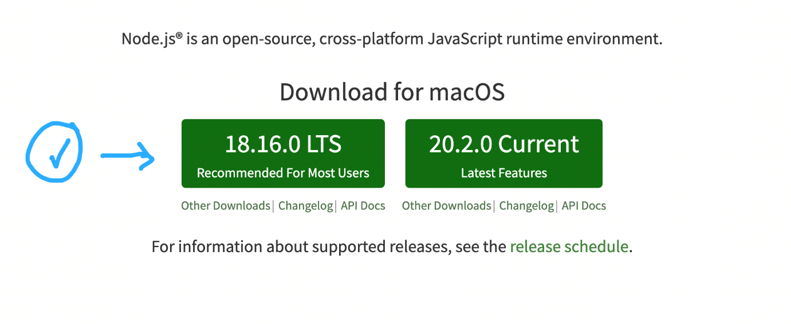
3. **Run the installer** (the .msi file you downloaded in the previous step.)
4. **Follow the prompts in the installer** (Accept the license agreement, click the NEXT button a bunch of times and accept the default installation settings).

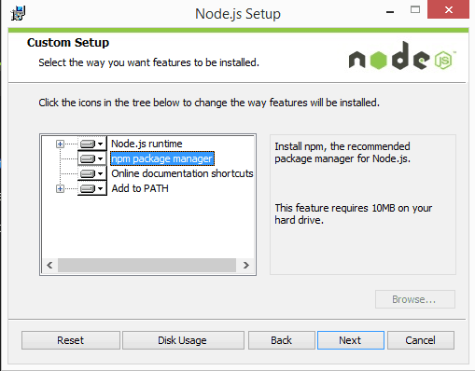

5.**Restart your computer.** You won’t be able to run Node.js® until you restart your computer.

6. Confirm that Node has been installed successfully on your computer by opening a Hyper terminal and typing in the commands node --version

You should see the version of node you just installed.